* Copyright for test papers and marking guides remains with *West Australian Test Papers*.
* The papers may only be reproduced within the purchasing school according to the advertised conditions of sale.
* Test papers must be withdrawn after use and stored securely in the school until Friday 4th December 2015.



**YEAR 11 PHYSICS**

**UNITS 1 & 2**

**2015**

**MARKING GUIDE**

## Section One: Short response 30% (54 Marks)

This section has **14** questions. Answer **all** questions.

When calculating numerical answers, show your working or reasoning clearly. Give final answers to **three** significant figures and include appropriate units where applicable.

When estimating numerical answers, show your working or reasoning clearly. Give final answers to a maximum of **two** significant figures and include appropriate units where applicable.

Spare pages are included at the end of this booklet. They can be used for planning your responses and/or as additional space if required to continue an answer.

* Planning: If you use the spare pages for planning, indicate this clearly at the top of the page.
* Continuing an answer: If you need to use the space to continue an answer, indicate in the original answer space where the answer is continued, i.e. give the page number. Fill in the number of the question that you are continuing to answer at the top of the page.

Suggested working time: 50 minutes.

## Question 1 (4 marks)

The kinetic particle model is based on some fundamental assumptions. List wo assumptions indicating the type of energy (potential and kinetic) involved.

* **Matter is made of particles in constant motion (EK)**
* **Collisions of particles are elastic (EK)**
* **Mutual attraction of particles (EP)**

**1 mark for each assumption + 1 mark for each energy type**

**Question 2 (5 marks)**

1. There are two types of β particles. Name them.

**Electron and positron** **(1 mark)**

1. What is the difference between these two particles?

**Electron -ve, positron +ve** **(1 mark)**

1. Complete the following table. **(3 marks)**

|  |  |
| --- | --- |
| Mass relative to a proton | **~1/2000** (1 mark) |
| Speed | **High** (1 mark) |
| Ionising Effect | **Weak** (1 mark) |

**Question 3 (5 marks)**

Electricians must replace fuses with residual current devices (RCD) when they do some work on houses in Western Australia.

1. Explain how RCDs protect people from electrocution. (2 marks)

**If there is an imbalance of current flowing into and out of the house of more than a predetermined amount (1 mark)**

**the RCD breaks the circuit in a very short time (1 mark)**

1. Even with RCDs protecting all circuits in a house can people, using electricity that is passing through the RCDs, still be electrocuted in that house? Explain.

Can they be electrocuted? **Yes** **(1 mark)**

Explain. (2 marks)

**If a person touches both wires (active & neutral) and becomes part of circuit (1 mark) and no current flows to Earth (1 mark)**

**Question 4 (3 marks)**

A squash player hits the ball at a speed of 35.0 m s-1 at an angle of 300 to the side wall of the court. The ball rebounds at 1200 to the original direction at a speed of 27.5 m s-1.

What is the change in velocity?

Hint: use scale diagrams.

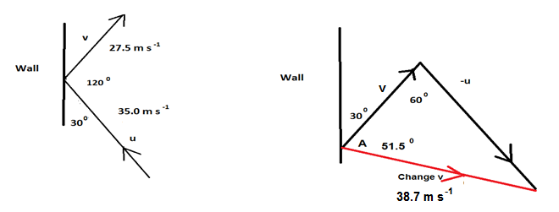

Calculation

Diagram **(1 mark)**

**Δv** **= ([-u]2 + v2 – 2 [-u]v cos 600)0.5**

**Δv** **= 38.7 m s-1** **(1 mark)**

**35 = 38.7**

**sin A sin 60**

**A = 51.50****(1 mark)**

Calculation to give expected answers. Also can resolve vectors to solve.

**Question 5 (3 marks)**

## Draw two graphs (displacement/time and displacement/distance) to represent a wave.

On these graphs label the period, amplitude and wavelength.

1. Displacement/time

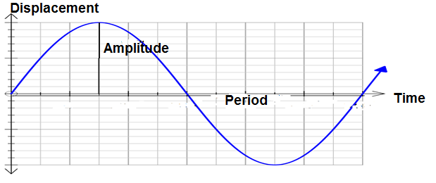

1. Displacement/distance

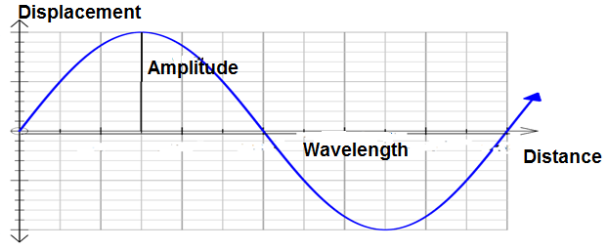

**1 mark for each: amplitude, wavelength & period**

**Question 6 (3 marks)**

On hot summer days at the cricket you can sometimes see players with a wet cloth around their necks. Referring to thermal concepts, explain how a wet cloth placed on the neck can help a person stay cool.

**Water evaporates (1 mark), water particles with highest EK leave (1 mark). Average EK lower hence lower temperature (1 mark)**

**Question 7 (6 marks)**

1. A violin string is 0.65 m in length. Sketch the standing waves produced and determine the wavelengths of the 1st and 2nd harmonics. (3 marks)

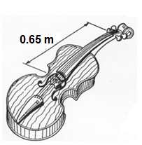

**1st SketchWavelength = 1.3 m**

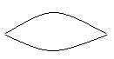

**2nd SketchWavelength = 0.65 m**



**1 mark for each sketch, 1 mark if both wavelengths**

b) If the wave speed on the string is 400 m s-1, calculate the frequencies of the first two harmonics? (3 marks)

**f = $\frac{c}{λ}$ 1 mark**

**1st f = $\frac{400}{1.3}=308 Hz$ 1 mark**

**2nd f = 2 x 308 = 615 Hz 1 mark**

**Question 8 (4 marks)**

A student heated 337 g of nickel in a Bunsen burner until it reached a temperature of 534 °C. She then placed the nickel into 1.59 L of water at a temperature of 21.0 0C. The final temperature of the nickel and water mixture was 32.3 °C when they reached thermal equilibrium.

1. Calculate the energy that transferred out of the nickel into the water. (2 marks)

**Q = m c ΔT = 1.59 x 4180 x 11.3 1 mark**

**Q = 7.51 x 104 J 1 mark**

1. Calculate the specific heat of the nickel. (2 marks)

**Q = m c ΔT c = $\frac{Q}{mΔT }$ $\frac{7.51 x {10}^{4}}{0.337 x 501.7}$ 1 mark**

**c = 444 J kg-1 K-1 1 mark**

**Question 9 (3 marks)**

A sample of thigh bone from a recently deceased dog was tested and found to have an activity of 0.360 Bq. A similar size sample was obtained from a sabre tooth tiger thigh bone uncovered at an archaeological site and its activity was measured. Over a one day period a reading of 7.776 x 103 counts was registered on a Geiger counter. The half-life of radioactive carbon is approximately 5730 years.

(a) Determine the activity (becquerels) for the archaeological sample. (1 mark)

**A = $\frac{N}{t}$ = $\frac{7776}{24 x 3600}$ = 9.00 x 10-2 Bq 1 mark**

(b) Determine the age of the thigh bone from the archaeological site. (2 marks)

**= n = = ()2 2 half lives 1 mark**

**2 x 5730 = 11 500 years 1 mark**

**Question 10 (2 marks)**

Write a balanced nuclear equation for the following decay:

Barium 141 (${}_{56}^{141}{Ba}$) by beta negative decay.

${}_{56}^{141}{Ba}$**→ ${}_{-1}^{0}e$ + ${}_{57}^{141}{La}$ + ${\overline{ν}}_{e}$ 2 marks**

**Question 11 (4 marks)**

1. Explain why gold is a better electrical conductor than rubber. (2 marks)

**Gold has free electrons due to its lattice structure and current flows (1 mark) whereas rubber has no free electrons (1 mark).**

1. Explain why gold is a better heat conductor than rubber. (2 marks)

**Gold has large numbers of delocalised electrons that transfer energy quickly (1 mark) compared to electrons fixed (rubber) (1 mark)**

**Question 12 (4 marks)**

1. When a resistor is connected to a battery, 6.02 × 1023 electrons pass through the resistor in a time of 70.0 s. Calculate the current in the resistor. (2 marks)

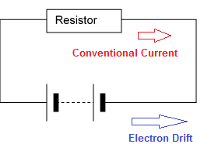

**I = $\frac{q}{t}$ = $\frac{1.6 x {10}^{-19} x 6.02 6.02 {10}^{23} }{70}$ 1 mark**

**I = 1.38 x 103 A 1 mark**

1. (i) Put a labelled arrow on the diagram to indicate the direction of net electron drift in this circuit. (1 mark)

(ii) Also, put a labelled arrow on the diagram to indicate the direction of conventional current in this circuit. (1 mark)

**Question 13 (5 marks)**

1. Blue light has a wavelength of 4.75 x 10-7 m in air. Calculate its frequency in this medium. (1 mark)

**f = $\frac{c}{λ}$**

**f = $\frac{{3.00 x 10}^{8}}{{4.75 x 10}^{-7}}$ = 6.32 x 1014 Hz 1 mark**

b) If the blue light travels at 2.00 x 108 m s-1 in glass, calculate its frequency and wavelength in glass. (2 marks)

**f = 6.32 x 1014 Hz 1 mark**

**λ = x 4.75 x 10-7 = 3.17 x 10-7 m 1 mark**

c) Blue light travels from air into a glass block at an angle of incidence of 300. Complete the diagram showing what happens at the surface. (Calculations NOT necessary.) (2 marks)

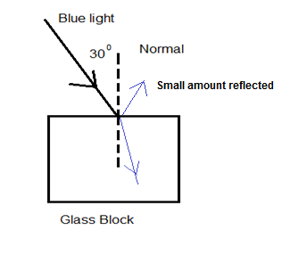

**1 mark for each ray** **(2 marks)**

**Question 14 (3 marks)**

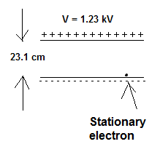

Calculate the work done (joules and electron volts) in accelerating the electron across the gap.

**V = 1.23 x 103 V**

**q = -1.60 x 10-19 C**

**V =**

**W = Vq = 1.23 x 103 x 1.60 x 10-19 1 mark**

**W = 1.97 x 10-16 J 1 mark**

**W = 1.23 x 103 eV 1 mark**

## Section Two: Problem-solving 50% (90 Marks)

This section has **seven (7)** questions. Answer **all** questions. Write your answers in the spaces provided.

Spare pages are included at the end of this booklet. They can be used for planning your responses and/or as additional space if required to continue an answer.

* Planning: If you use the spare pages for planning, indicate this clearly at the top of the page.
* Continuing an answer: If you need to use the space to continue an answer, indicate in the original answer space where the answer is continued, i.e. give the page number. Fill in the number of the question that you are continuing to answer at the top of the page.

Suggested working time: 90 minutes.

## Question 15 (13 marks)

Bernard Tomic celebrates a victory by climbing into the crowd and smashing a tennis ball vertically upwards.

The ball is hit from a position 2.75 m above the ground with an initial velocity of 55.1 m s-1 upwards.

The ball has a mass of 57.3 g.

1. Calculate the time that the ball takes to reach the ground. (3 marks)

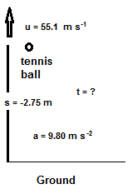 **up is +ve**

**s = ut + 0.5 at2**

**-2.75 = 55.1 t -4.9 t2**

**t = 1.13 x 101 s**

1. Calculate the velocity of the ball after 5.10 s. (2 marks)

**t = 5.10 s**

**v = u + at = 55.1 – 9.8 x 5.1 1 mark**

**v = 5.12 m s-1 1 mark**

1. Calculate the distance that the ball travels to reach the ground. (3 marks)

**Highest point v = 0 v2 = u2 + 2as 0 = 55.12 -19.6 s 1 mark**

**s = 1.55 x 102 m 1 mark**

**Total distance = (2 x 1.55 x 102) + (2.75) = 3.13 x 102 m 1 mark**

1. Calculate the mechanical energy of the ball whilst in flight. (3 marks)

**EM = EK + EP 1 mark**

**= 0.5 mv2 + mgh = 0.5 x 0.0573x 55.12 + 0.0573 x 9.8 x 2.75 1 mark**

**= 8.85 x 101 J 1 mark**

1. The tennis racquet is in contact with the ball for 0.312 s. Calculate the impulsive force on the ball. (2 marks)

**F = (mv – mu)/t = 0.0573 (55.1 -0)/0.312 1 mark**

**F = 1.01 x 101 N 1 mark**

**Question 16 (22 marks)**

A group of Physics students wanted to measure the speed of sound in air using two methods. The air temperature is 25 0C.

1. For the first method they had the following equipment available to them:

Stop watch, starting pistol, a dark wall on the edge of an oval, a tape measure

1. For the second method they had the following equipment available to them:

A 4.80 x 102 Hz tuning fork, large measuring cylinder, ruler, water, round tubes of various lengths that fit inside the measuring cylinder

1. (i) Design an experiment to determine the speed of sound using all the equipment in the first list. (5 marks)

**Dark wall back drop so can see smoke from starter’s pistol**

**Tape measure out 100 m from pistol**

**Observer @ 100 m**

**Stop watch time from seeing smoke & then hearing sound.**

**Calculate using s/t**

**1 mark for each**

(ii) Create one set of data for this experiment and show how the speed of sound can be calculated using that data. (3 marks)

**s = 100 m 1 mark**

**t = 0.289 s 1 mark**

**c = s/t = 100/0.289**

**c = 346 m s-1 1 mark if 346 as T = 25 0C**

1. (i) Design an experiment to determine the speed of sound using all the equipment in the second list. (5 marks)

**Nearly full measuring cylinder with water, place round tube in water 1 mark**

**Place vibrating tuning fork over tube & find 1st resonant point 1 mark**

**Measure with ruler 1 mark**

**Repeat to find 2nd resonant point 1 mark**

**Calculate 2 x (R2 – R1) x 480 = c 1 mark**

(ii) Create one set of data for this experiment and show how the speed of sound can be calculated using that data. (3 marks)

**R1 = 0.172 m R2 = 0.532 m 1 mark**

**R2 – R1 = 0.532 – 0.172 = 0.360 m 1 mark**

**c = 2 x 0.360 x 480 = 346 m s-1 1 mark**

1. (i) Design an experiment using all the equipment in the first list to determine the minimum time that must occur between hearing the original sound and its echo. (5 marks)

**Observer and pistol shooter stand next to each other 1 mark**

**Stand in front of wall (sound bounces off) 1 mark**

**Move away from wall 1 mark**

**Fire pistol at set distance (ruler) and listen for echo (hear sound twice) 1 mark**

**When hear echo first time measure time 1 mark**

(ii) Explain why there must be a minimum time between the original sound and its echo for the observer to distinguish them as two separate sounds. (1 mark)

**The human brain needs ~ 0.1 s to distinguish the two sounds 1 mark**

**Question 17 (15 marks)**

Some liquid alcohol of mass 1.30 g was placed in a sealed glass container and vaporised at 70 ºC.

The container with the vapour was placed in a large water bath that was kept at room temperature. The change in temperature of the alcohol was recorded every two minutes. There was constant rate of energy output from the alcohol such that 2330 J of energy was transferred out in a 50 minute time period.

Assume that heat loss to the surroundings was negligible.

Room temperature was 26 0C.

|  |  |  |  |  |  |  |  |  |  |  |
| --- | --- | --- | --- | --- | --- | --- | --- | --- | --- | --- |
| **Temp**  **(0C)** | **Time**  **(minutes)** |  | **Temp**  **(0C)** | **Time**  **(minutes)** |  | **Temp**  **(0C)** | **Time**  **(minutes)** |  | **Temp**  **(0C)** | **Time**  **(minutes)** |
| 70 | 0 |  | 42 | 14 |  | 42 | 28 |  | 35 | 42 |
| 64 | 2 |  | 42 | 16 |  | 42 | 30 |  | 33 | 44 |
| 59 | 4 |  | 42 | 18 |  | 42 | 32 |  | 31 | 46 |
| 53 | 6 |  | 42 | 20 |  | 42 | 34 |  | 29 | 48 |
| 48 | 8 |  | 42 | 22 |  | 41 | 36 |  | 27 | 50 |
| 42 | 10 |  | 42 | 24 |  | 39 | 38 |  | 26 | 52 |
| 42 | 12 |  | 42 | 26 |  | 37 | 40 |  | 26 | 54 |

1. Draw a graph of the data in the table. (5 marks)

A spare grid is at the end of the paper in case you need to redo your graph.

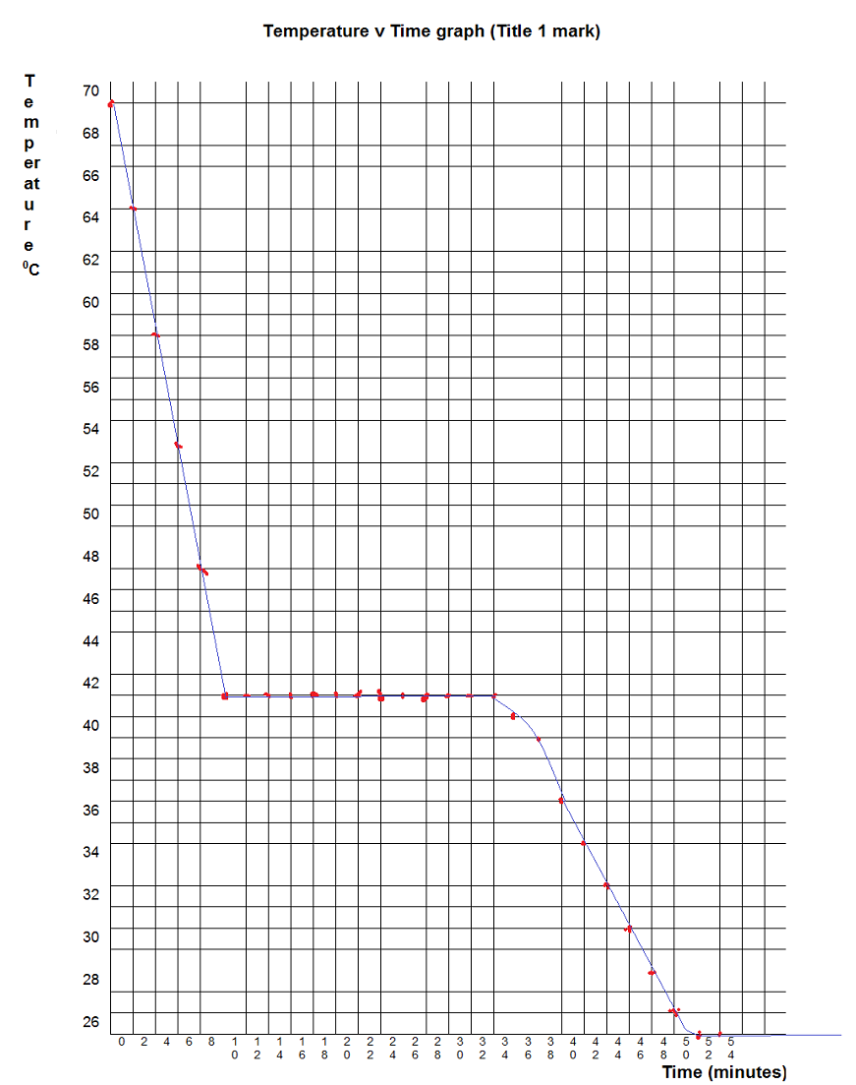

**1 mark for each labelled axis with**

**1 for accuracy**

**1 for line of best fit**

b) Using the graph compare (quantitatively) the specific heat capacity of the liquid alcohol with the specific heat capacity of its vapour? (3 marks)

**50 minute is 2330 J vapour 10 minutes = 2330 x 10/50 = 466 J**

**c = Q/m ΔT = 466/(1.3 x 10-3 x 28) = 1.28 x 104 J kg-1 K-1 1 mark**

**liquid 10 minutes 466 J**

**c = Q/m ΔT = 466/(1.3 x 10-3 x 10) = 3.58 x 104 J kg-1 K-1 1 mark**

**cliquid/cvapour = 3.58/1.28 = 2.80 OR cliquid  3 x cvapour 1 mark**

c) What state/s of matter is/are present in the container between fifteen and twenty five minutes? (1 mark)

**gas/liquid 1 mark**

1. There was constant rate of energy output from the alcohol such that 2330 J of energy was transferred out in a 50 s time period. This assumption was used to enable calculations to be carried out.

Explain what is wrong with this assumption. You can still assume that heat loss to the surroundings was negligible. (2 marks)

**As temp difference decreases (1 mark) heat transfer is smaller (1 mark)**

1. Determine the latent heat of vaporisation of the alcohol. (2 marks)

**Q = 2330 x 24/50 = 1.12 x 103 J 1 mark**

**L = Q/m = 1.12 x 103/1.3 x 103 = 8.60 J kg-1 1 mark**

1. In terms of energy, explain why the temperature of the substance did not decrease while energy transferred from it to the water between fifteen and thirty minutes. (2 marks)

**Temp did not decrease no change in EK 1 mark**

**Particle got closer together decrease in EP 1 mark**

**Question 18 (16 marks)**

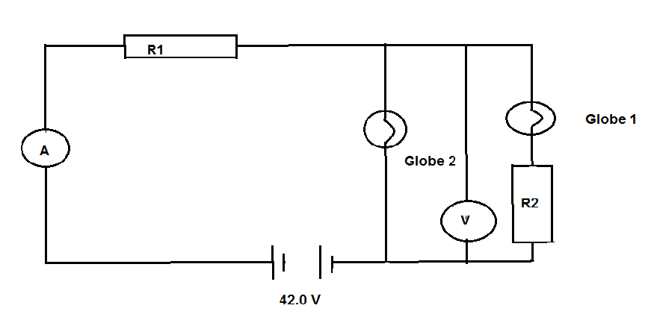

Globe 1 is rated at 12.0 V and 3.00 W

Globe 2 is rated at 36.0 V and 12.0 W

Assume that this circuit allows both globes work at the exact values at which they are rated.

1. Determine:
2. Current in Globe 1 (2 marks)

**P = 3.0 W V = 12.0 V**

**I = P/V = 3/12 1 mark**

**I = 0.250 A 1 mark**

1. Current in Globe 2 (2 marks)

**P = 12.0 W V = 36.0 V**

**I = P/V = 12/36 1 mark**

**I = 0.333 A 1 mark**

1. Resistance of R2 (3 marks)

**V = 36 – 12 = 24 1 mark**

**I = 0.250 A**

**R = V/I = 24/0.250 1 mark**

**R = 96.0 Ω** **1 mark**

1. Resistance of R1 (3 marks)

**V = 6 V 1 mark**

**I = (0.333 + 0.250) = 0.583 A 1 mark**

**R = V/I = 6/0.583**

**R = 10.3 Ω 1 mark**

(iv) The total resistance of the circuit (3 marks)

**V = 36 V 1 mark**

**I = (0.333 + 0.250) = 0.583 A 1 mark**

**R = V/I = 36/0.583**

**R = 61.7 Ω 1 mark**

1. What is the reading on the:
2. ammeter (2 marks)

**0.583 A 2 marks**

1. voltmeter (1 mark)

**36.0 V 1 mark**

**Question 19 (9 marks)**

A keen bushwalker went for an extended hike as shown by the following graph.

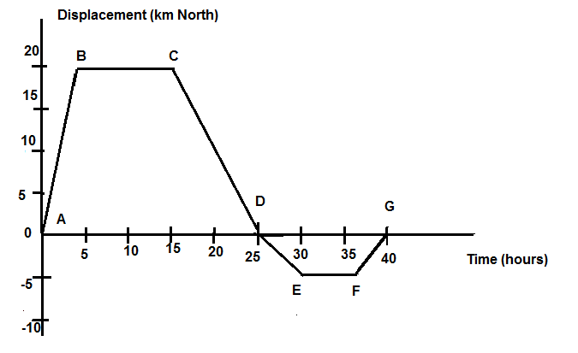

Use the graph to determine the following information:

1. How far did the hiker walk? (1 mark)

**50 km 1 mark**

1. Calculate the velocity (km h-1) in the following segments:
2. AB (1 mark)

**5 km h-1 N 1 mark**

1. EF (1 mark)

**0 km h-1 1 mark**

1. AG (1 mark)

**0** **km h-1 1 mark**

1. DE (1 mark)

**1 km h-1 S 1 mark**

1. Draw a graph of velocity versus time. (3 marks)

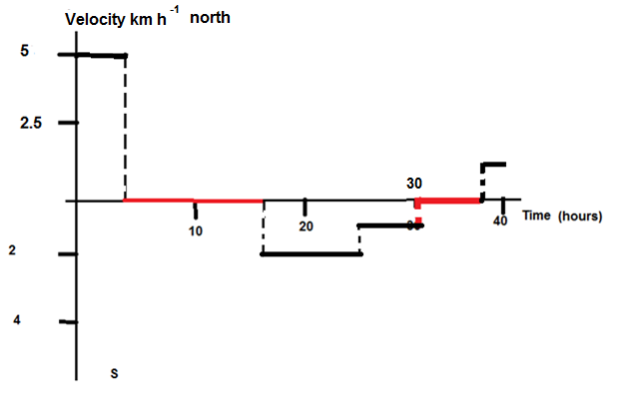

**3 marks**

1. For how long was the walker stationery? (1 mark)

**17 +/- 2 hours 1 mark**

**Question 20 (6 marks)**

The graph below shows the binding energy per nucleon versus mass number for the nuclei of some common isotopes.

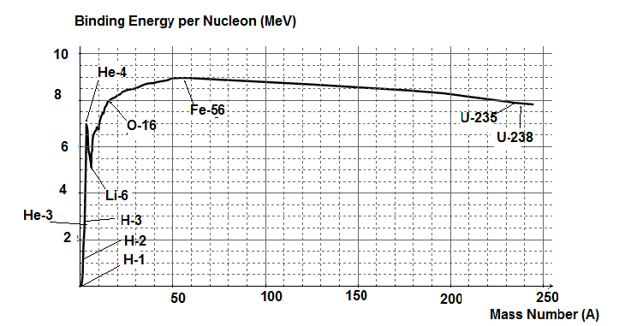

1. From the graph estimate the average binding per nucleon (MeV) of the hydrogen-2 nucleus. (1 mark)

**1.1 MeV/nucleon 1 mark**

1. Refer to the graph to explain which elements can undergo nuclear fusion and release energy. (2 marks)

**Left of Fe- 56 1 mark**

**As particle combine MeV/Nucleon increases 1 mark**

1. Estimate the difference in mass between a lithium-6 nucleus and the individual nucleons that go into making the nucleus. State your answer in atomic mass units. (3 marks)

**5 MeV/nucleon 1 mark**

**1 u = 931 MeV 1 mark**

**Mass difference = 5/931 u = 5.37 x 10-3 u 1 mark**

**Question 21 (9 marks)**

Compact fluorescent globes are becoming more popular and eventually you will not be able to buy incandescent globes. A compact fluorescent globe was advertised at a rating of 18.0 W but with equal brightness to that of a 100.0 W incandescent globe.

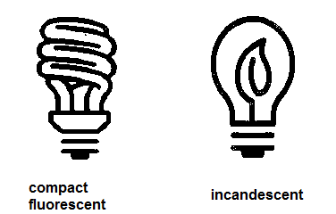

a) What is the essential difference between these globes and why is the incandescent globe being phased out? (3 marks)

**Incandescent relies on heating a metal filament (1 mark)**

**Fluorescent relies on exciting electrons and then allowing them to return emitting emr that is absorbed by fluorescent powder which emits light (1 mark)**

**Incandescent gets much hotter (waste) 1 mark**

b) If the compact fluorescent globe is assumed to be 80.0% efficient, what is the efficiency of the incandescent globe? (2 marks)

**80% x 18 = 14.4 W 1 mark**

**14.4/100 = 14.4% efficient 1 mark**

c) Assuming the waste energy in both types of globe is released as heat, calculate the heat lost by each of the globes in one hour.

(i) compact fluorescent globe (3 marks)

**W = P x t 1 mark**

**W = 3.6 x 3600 1 mark**

**W = 1.30 x 104 J 1 mark**

(ii) incandescent globe (1 mark)

**W = 85.6 x 3600 = 3.08 x 105 J 1 mark**

|  |  |  |
| --- | --- | --- |
| **Section Three: Comprehension** |  | **20% (36 Marks)** |

This section has **two (2)** questions. You must answer **both** questions. Write your answers in the spaces provided.

Spare pages are included at the end of this booklet. They can be used for planning your responses and/or as additional space if required to continue an answer.

* + - Planning: If you use the spare pages for planning, indicate this clearly at the top of the page.
    - Continuing an answer: If you need to use the space to continue an answer, indicate in the original answer space where the answer is continued, i.e. give the page number. Fill in the number of the question that you are continuing to answer at the top of the page.

Suggested working time: 40 minutes.

## Question 22 (20 marks)

**Alpha Particles Target Cancer**

**By Calla Cofield**

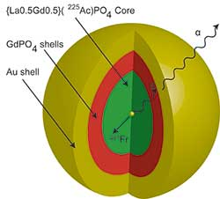  
Photo courtesy of J. David Robertson/University of Missouri

In 2013, the Food and Drug Administration (FDA) approved the first cancer treatment drug containing an alpha-emitting isotope. In a 2014 APS Meeting, J. David Robertson, professor of chemistry at the University of Missouri, discussed a new technique that involves embedding alpha emitters inside a layered, gold-coated nanoparticle to make them safe for treatment for even more cancers.

Endoradiotherapy is a form of internal radiation therapy in which a radioactive substance is ingested by, or injected into the patient. Until last year endoradiotherapy used beta emitters. While surgery is usually the best option for sizeable, isolated tumours, chemotherapy is utilized to destroy small groups of cancer cells (or “micrometastases”) in multiple locations.

Endoradiotherapy drugs offer a targeted alternative to chemotherapy for attacking micrometastases. The drugs can be engineered to bind to receptors that are found on the cancer cells. When released nearby, beta particles do significant damage to cell DNA by ionizing other atoms and creating reactive chemical species in the cells.

Alpha particles are more direct, delivering energy directly to the cell DNA and fatally disrupting chemical reactions. And while beta particles deliver a few hundred keV of energy over a few millimetres, alpha particles deliver a bigger punch of 5 MeV, but stop after a distance of a few microns. “That very large amount of energy deposited in short range…makes them more cytotoxic to the cell than beta emitters,” said Robertson. “And it will allow you to get the same therapeutic effect with [about an order of magnitude] less radioactivity.”

Robertson and his collaborators from Oak Ridge National Laboratory and the University of Tennessee are in the preclinical phase of research to adapt the alpha emitter actinium 225 for endoradiotherapy. The isotope has a half-life of 11 days, which is ideal, since it gives the researchers plenty of time to synthesize the drug (about 2 days) and then let it pass through the body and accumulate at the target site (another 2 to 3 days).

But decaying particles come with certain challenges: In the case of Ac-225, the alpha particle breaks free of the actinium nucleus with an energy of 5 to 6 MeV. This gives the daughters of the actinium a kick of about 100 keV, which is more than enough to tear through a molecular chain or a layer of cells, and send the daughters traveling through the body. The isotope Ac-225 eventually decays to bismuth, which has a 46-minute half-life and can be toxic if it builds up in the kidneys.

Robertson and his colleagues think they have found a solution: wrap the actinium in a layered nanoparticle to absorb the recoil energy and contain the daughter isotopes. The final product includes inner layers of lanthanide phosphate and gadolinium phosphate, and an outer layer of gold. The alpha particles still manage to escape the nanoparticle with only 0.1% energy loss, but after 24 hours 90% of the bismuth is contained in the nanoparticle or in nearby cells. Robertson says previous efforts to contain the bismuth by product of Ac-225 decay have succeeded in containing only 10 to 20 percent.

“We’re close to the goal of 100% [retention of bismuth],” said Robertson. The gold nanoparticle is currently being tested in the first phase of preclinical trials. Now Robertson and colleagues will have to see if the retention of bismuth is good enough to justify using the drug in humans. It comes down to the same question that doctors must ask of so many cancer drugs - “Does the benefit outweigh the risk?”

1. Why is the gold coating on the nanoparticle important for its operation and the safety of the patient? (3 marks)

**Only 0.1% energy loss as alpha (α) passes out of nanoparticle 1 mark**

**Retains Bismuth 1 mark**

**Retains recoil 1 mark**

1. Ac-255 decays to daughter particle with a half-life of 11 days. Each reaction is through an alpha decay. Write balanced nuclear equations for each of the decays: Name the daughter particles produced in each of these decays.

(6 marks)

${}_{89}^{255}{Ac}$**→ ${}_{2}^{4}{He}$ + ${}_{87}^{251}{Fr}$ Francium**

${}_{87}^{251}{Fr}$**→ ${}_{2}^{4}{He}$ + ${}_{85}^{247}{At}$ Astatine**

${}_{85}^{247}{At}$**→ ${}_{2}^{4}{He}$ + ${}_{83}^{243}{Bi}$ Bismuth**

**1 for each equation, 1 for each name**

1. (i) Beta particles have a quality factor of 1 whereas alpha particles has a quality factor of 20. Using the article what two factors account for this?

(2 marks)

**Directly attack DNA 1 mark**

**Bigger punch 5 Mev compared with a few hundred keV 1 mark**

(ii) Gamma particles also have a quality factor of 1. What additional factor helps account alpha’s greater quality factor compared with gamma?

(1 mark)

**Large mass OR large charge 1 mark**

1. An alpha particle has a mass of 6.64424 x10-27 kg. With what velocity does the alpha particle break free of the actinium nucleus? (3 marks)

**EK = 0.5mv2**

**EK = 5 MeV = 5 x 1.6 x 10-13 J 1 mark**

**v = (EK/0.5 x m)0.5 = (8 x 10-13/0.5 x 6.64 x 10-27)0.5 1 mark**

**v = 7.76 x 106 m s-1 1 mark**

1. (i) Alpha particles in the body travel a few microns compared with a few millimetres for beta. Compare the volume affected by beta compared with affected by alpha? (2 marks)

**mm is 103 bigger than micron 1 mark**

**V increase by 109 1 mark**

(ii) Beta particles ionise atoms. Explain how this occurs? (1 marks)

**Fast moving e-s collide with the atom causing an e- to be removed 1 mark**

(iii) The beta particles do significant damage to cell DNA. How does this help destroy the cancer? (2 marks)

**DNA not able to carry out normal reactions 1 mark**

**Not able to replicate hence dies 1 mark**

**Question 23 (16 marks)**

**How Safe is Your Car**

**Crash Protection Features**

Crash protection features provide greater levels of injury protection to drivers and passengers in car crashes, they include:

**Crumple zones**

Modern cars protect drivers and passengers in frontal, rear and offset crashes by using crumple zones to absorb crash energy. This means that the car absorbs the impact of the crash, not the driver or passengers.

**Strong occupant compartment**

The cabin of the car should keep its shape in frontal crashes to protect the driver and passenger’s space. The steering column, dashboard, roof pillars, pedals and floor panels should not be pushed excessively inwards, where they are more likely to injure drivers and passengers. Doors should remain closed during a crash and should be able to be opened afterwards to assist in quick rescue, while strong roof pillars can provide extra protection in rollover crashes.

**Side impact protection**

Increased side door strength, internal padding and better seats can improve protection in side impact crashes. Most new cars have side intrusion beams or other protection within the door structure. Some cars also have padding on the inside door panels.

Increasingly, car manufacturers are installing side airbags that provide protection from severe injury. Head-protecting side airbags, such as [curtain airbags](http://www.howsafeisyourcar.com.au/Curtain-Airbags/), are highly effective in side impact and rollover crashes.

[**Seat belts**](http://www.howsafeisyourcar.com.au/Safety-Features/Safety-Features-List/Seatbelt-Pretensioner-Driver/)

A properly worn seat belt provides good protection but does not always prevent injuries. Three point lap/sash seat belts offer superior protection to two point seat belts and should be installed in all seating positions. Recent improvements to seat belt effectiveness include:

* webbing clamps that stop more seat belt reeling out as it tightens on the spool
* pretensioners that pull the seat belt tight before the occupant starts to move
* load limiters that manage the forces applied to the body in a crash
* seat belt warning systems to remind you if seat belts have not been fastened.

[**Airbags**](http://www.howsafeisyourcar.com.au/Safety-Features/Safety-Features-List/Front-Airbags-Driver/)

Australian airbags are designed to supplement the protection provided by seat belts - they are not a substitute. The best protection in frontal crashes is achieved using a properly worn seat belt in combination with an airbag.

[**Head rests**](http://www.howsafeisyourcar.com.au/Safety-Features/Safety-Features-List/Head-Restraints-All/)

Head rests are important safety features and should be fitted to all seats - front and back. Head rest position is critical for preventing whiplash in rear impact crashes. Whiplash is caused by the head extending backward from the torso in the initial stage of rear impact, then being thrown forward. To prevent whiplash the head rest should be at least as high as the head's centre of gravity (eye level and higher) and as close to the back of the head as possible.

Diagram and Information courtesy of Folksam Research, 2005 (SWEDEN)

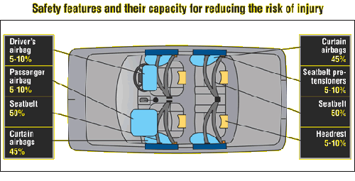

1. “Modern cars protect drivers and passengers in frontal, rear and offset crashes by using crumple zones to absorb crash energy.” (2 marks)

Explain the energy transformations that occur when a car’s crumple zone absorbs energy in a crash.

.

**EK of car (1 mark) is converted to noise, heat and deforming (1 mark)**

1. Crumple zones also reduce the force experienced when a car crashes. Explain, using Newton’s Second Law (momentum) how this acts as an additional safety feature in a car. (4 marks)

**Newton’s Second Law commonly written as F = ma 1 mark**

**Can be rewritten as F = (mv – mu)/t 1 mark**

**t increases 1 mark**

**F decreases, hence less force on occupants 1 mark**

1. Two point seat belts are belts that fit across the driver’s or passenger’s lap. The two points were generally on the floor. Modern car seat belts have a third point about shoulder height when sitting. Why is this advantageous? (2 marks)

**Better at keeping occupant in place 1 mark**

**Prevents body/head for going forward and hitting something 1 mark**

1. You are in the passenger seat holding a 3.00 kg parcel on your lap. Your car is involved in a head on crash with a tree. The car speed goes from 72.0 km h-1 to zero in 0.100 s. What force is required to hold the parcel? (3 marks)

**m = 3 kg v = 0 t = 0.100 s**

**u = 72.0 km h-1 = 72/3.6 = 20 m s-1 1 mark**

**F = (mv- mu)/t = (3 x 0 – 3 x 20)/0.100 1 mark**

**F = 6.00 x 102 N 1 mark**

1. Head rests reduce whiplash injuries in car crashes. Identify and use the appropriate Newton’s Law to explain why this is so. (3 marks)

**Whiplash is generally caused by crashes where the person is in the vehicle hit from behind 1 mark**

**According to Newton’s First Law the unrestrained head continues forward and then body “jerks” it back 1 mark**

**The head rest reduces how far back the head can snap back 1 mark**

1. Airbags inflate and then deflate very quickly. Why? (2 marks)

**Inflate quickly to prevent head hitting solid object 1 mark**

**Deflate quickly to prevent suffocation 1 mark**

**Acknowledgements**

Question 22 – Calla Caulfield, Alpha Particles Target Cancer from

APS News published by the American Physical Society (June 2014)

Reprinted with permission of the Editor, APS News.

Question 23 – How Safe Is Your Car?

Reprinted with permission from the Transport Accident Commission of Victoria and Folksam Research of Sweden